DATE:28-1-2021

NAME:GOWTHAM NARAYANA

ID NO:20BCD7172

EXPERIMENT NO.10

**AIM:** To verify the THEVENIN’S THEOREM in a circuit.

**SOFTWARE USED**: NI MILTISIM 14.2

**THEORY:**

* THEVENIN’S THEOREM states that any complicated network across its load terminals can be substituted by a voltage source (VTH) with one resistance (RTH) in series.
* This theorem helps in the study of the variation of current in a particular branch when the resistance of the branch is varied while the remaining network remains the same.
* VTH – open circuit voltage at terminals,
* RTH – Input/Equivalent resistance at the terminals when the independent sources are turned off.

**CIRCUIT DIAGRAMS:**

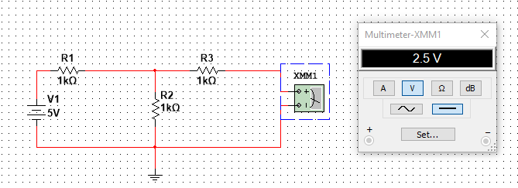

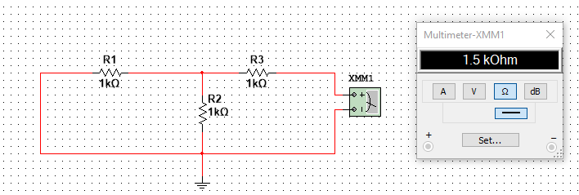

**OBSERVATIONS:**

|  |  |  |  |  |  |  |  |
| --- | --- | --- | --- | --- | --- | --- | --- |
| SOURCE VOTAGE(VS) | R1 | R2 | R3 | VTH(Theoretical) | VTH(Multisim) | RTH(Theoretical) | RTH(MULTISIM) |
| 5V | 1KΩ | 1KΩ | 1KΩ | 2.5V | 2.5V | 1.5KΩ | 1.5KΩ |
| 2.5V | 1.5KΩ | 3KΩ | 1.1KΩ | 1.667V | 1.667V | 2.1KΩ | 2.1KΩ |
| 10V | 2.5KΩ | 5KΩ | 3.5KΩ | 6.667V | 6.667V | 5.167KΩ | 5.167KΩ |
| 8V | 7.5KΩ | 6.5KΩ | 5.0KΩ | 3.714V | 3.714V | 8.482KΩ | 8.482KΩ |
| 3V | 3.2KΩ | 2.1KΩ | 0.5KΩ | 1.189V | 1.189V | 1.768KΩ | 1.768KΩ |

RESULTS:

Thevenin’s theorem is verified.

EXPERIMENT-1

**AIM:**

Colour code of resistors and verification of series and parallel combination of R,C.

**SOFTWARE USED**:

NI MULTISIM 14.2

**THEORY:**

**a) Resistor Colour code**:

* 1. 1. Hold a resistor in your hand. The section with more number of band should be on left side. After the gap, on right side should be one/two band indicating tolerance or temperature co-efficient.
  2. Write on paper in capital letters i.e., BOGY(GAP)YS, the Colour starting from left to right.
  3. Replace the colours with numbers that will be the value of resistor resistance i.e., 035×104 ± 3%. Cross verification can be done using digital multi-meter.

1. **Series and parallel combination of R and C**
   1. Pick three resistors rated at R1=1 kΩ, R2=2 kΩ, and R3=3 kΩ. Measure their values in the using multimeter.
   2. Construct, one at a time, arrangements shown in Fig 2(a) and Fig. 2(b) on breadboard. Set the supply to 20 V.
   3. For each arrangement, measure the indicated variables.
   4. Repeat the same experiment with three different value of C. Use a function generator as AC power supply. Measure the RMS value of voltage and current, using multimeter. To verify series and parallel connection of C and note down absolute value of reading.

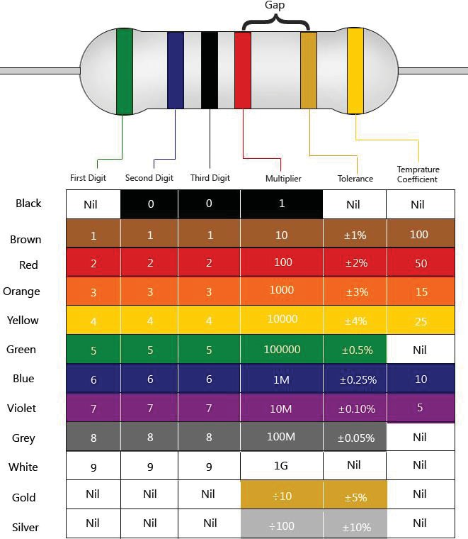**CIRCUIT DIAGRAM**:

1. Colour codes

**OBSERVATION:**

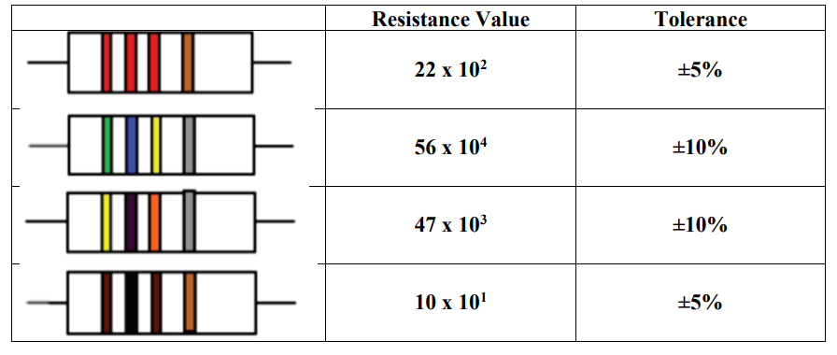

**RESULT:**

From this we were able to detect the resistance of a resistor using Colour code.